Discrete Distributions

[John S Butler (TU Dublin)](https://johnsbutler.netlify.com)

# Introduction

# Binomial Distribution

## Definition:

{p{k}(1-p){n-k}}

In R code:

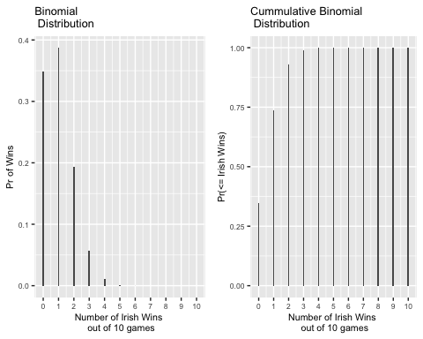

# Geometric Distribution

## Definition:

{p{k}(1-p){n-k}}

In R code:

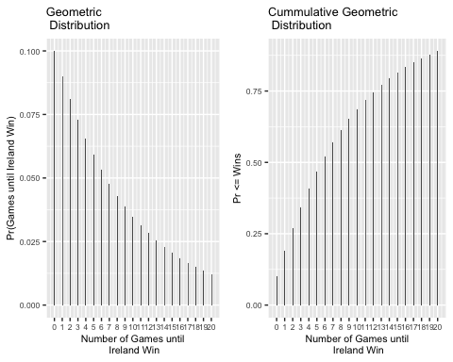

# Poisson Distribution

## Definition:

{p{k}(1-p){n-k}}

In R code:

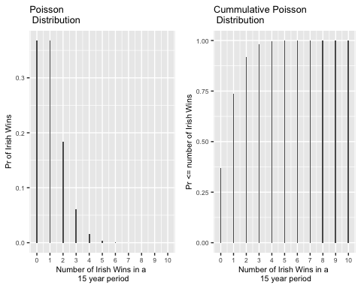 # Normal Distribution

## Definition:

{p{k}(1-p){n-k}}

In R code:

## Warning: Ignoring unknown parameters: width  
  
## Warning: Ignoring unknown parameters: width

